Adding Library Support in Arduino IDE
- To Add a library support to Arduino IDO, go to Sketch > Include Library > Add a .Zip Library, as shown in the figure below.
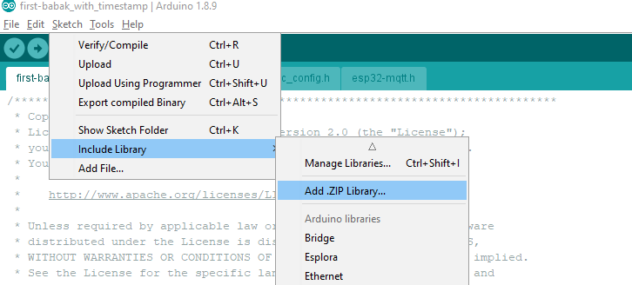
- This will open a browse menu from where you can navigate to the directory where the .Zip library file is present.
- Double click on the file to add it to the list of added libraries in Arduino IDE.

